2022 IONQ Mentoring Program Report

|  |  |  |  |  |
| --- | --- | --- | --- | --- |
| Team Name | CaptainQ | IonQ Mentor | | Daiwei Zhu |
| Team Member | Hwan-Seop Yeo  Seungwook Woo  Beomgyu Choi | Meeting | | 8:30 AM KST  24-May-2022  (Week 2) |
| Project Title | Improvement of Toffoli-n gate fidelity for Grover’s search algorithm | | | |
| Meeting | | | Meeting | |
| I:\8. IONQ\[2022.05] 멘토링 프로그램\Weekly report\week2-1.PNG | | |  | |

**Contents**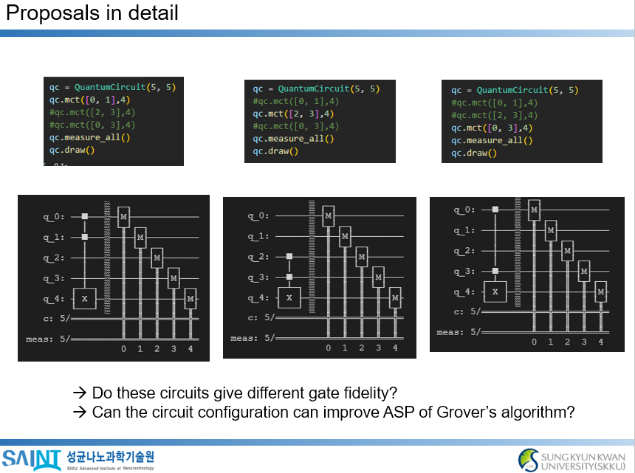

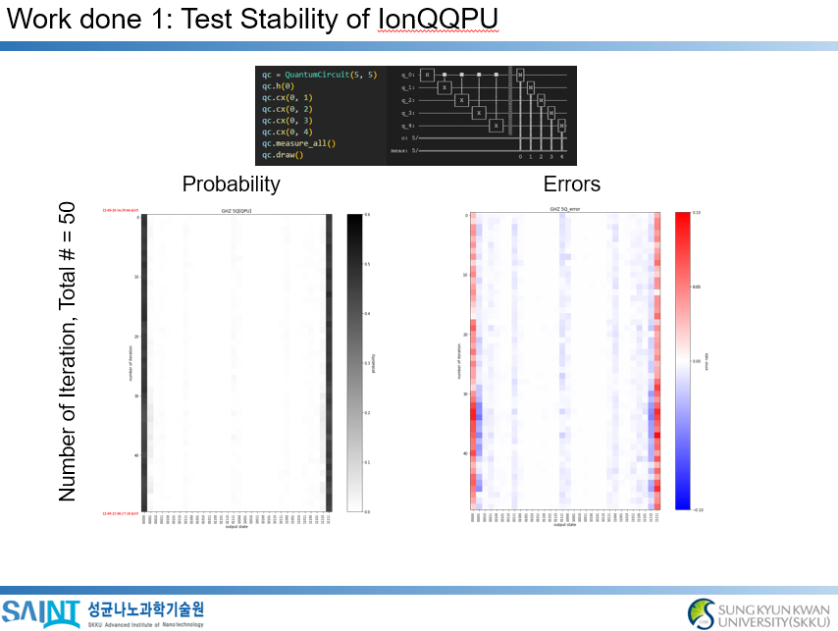

Future work:

1. Reproducing the results of the literatures (Toffoli-3 gate fidelity)
2. Measurement of 5-qubit GHZ states in different circuit configuration